Student’s Name
Professor’s Name
Course
Date
Solutions
- a. (g _{o} f)(x) = g(f(x)) = g(7x+2) = $\frac{3}{\left(7x+2\right)-11}= \frac{3}{7x-9}$
Domain: $\left(-∞, \frac{9}{7}\right)∪\left(\frac{9}{7},∞\right)$
b. (g _{o} f)(-1) $= \frac{3}{7\left(-1\right)-9}= \frac{-3}{16}$
c. (f _{o} g)(10) = g(f(10)) = g(7x+2) = $7\left(\frac{3}{x-11}\right)+2= \frac{2x-1}{x-11}$
(f _{o} g)(10) = $\frac{2\left(10\right)-1}{\left(10\right)-11}= -19$
- H(x) = $\frac{1}{{(3x-8)}^{2}}=f(g\left(x\right))$
H(x) = $\frac{1}{{(g\left(x\right))}^{2}}$ => g(x) = 3x – 8 and f(x) = $\frac{1}{x^{2}}$
- a. A = {(1, -4), (3,7), (6,6), (-3,2)}
A⁻¹ = {(-4,1), (7,3), (6,6), (2, -3)}
b. A⁻¹(7) = 7{(-4,1), (7,3), (6,6), (2, -3)}
= {(-28,7), (49,21), (42,42), (14, -21)}
- It must be a one to one
- a. let y = $\frac{9}{x-6}-2$
y+2 = $\frac{9}{x-6}$
Therefore, x = $\frac{9}{y+2}+6$
f⁻¹(x) = $\frac{9}{x+2}+6$
b. (-∞, 6)U(6, ∞)
c. (-∞, -2)U(-2, ∞)
d. (-∞, -2)U(-2, ∞)
e. (-∞, 6)U(6, ∞)
- .
- 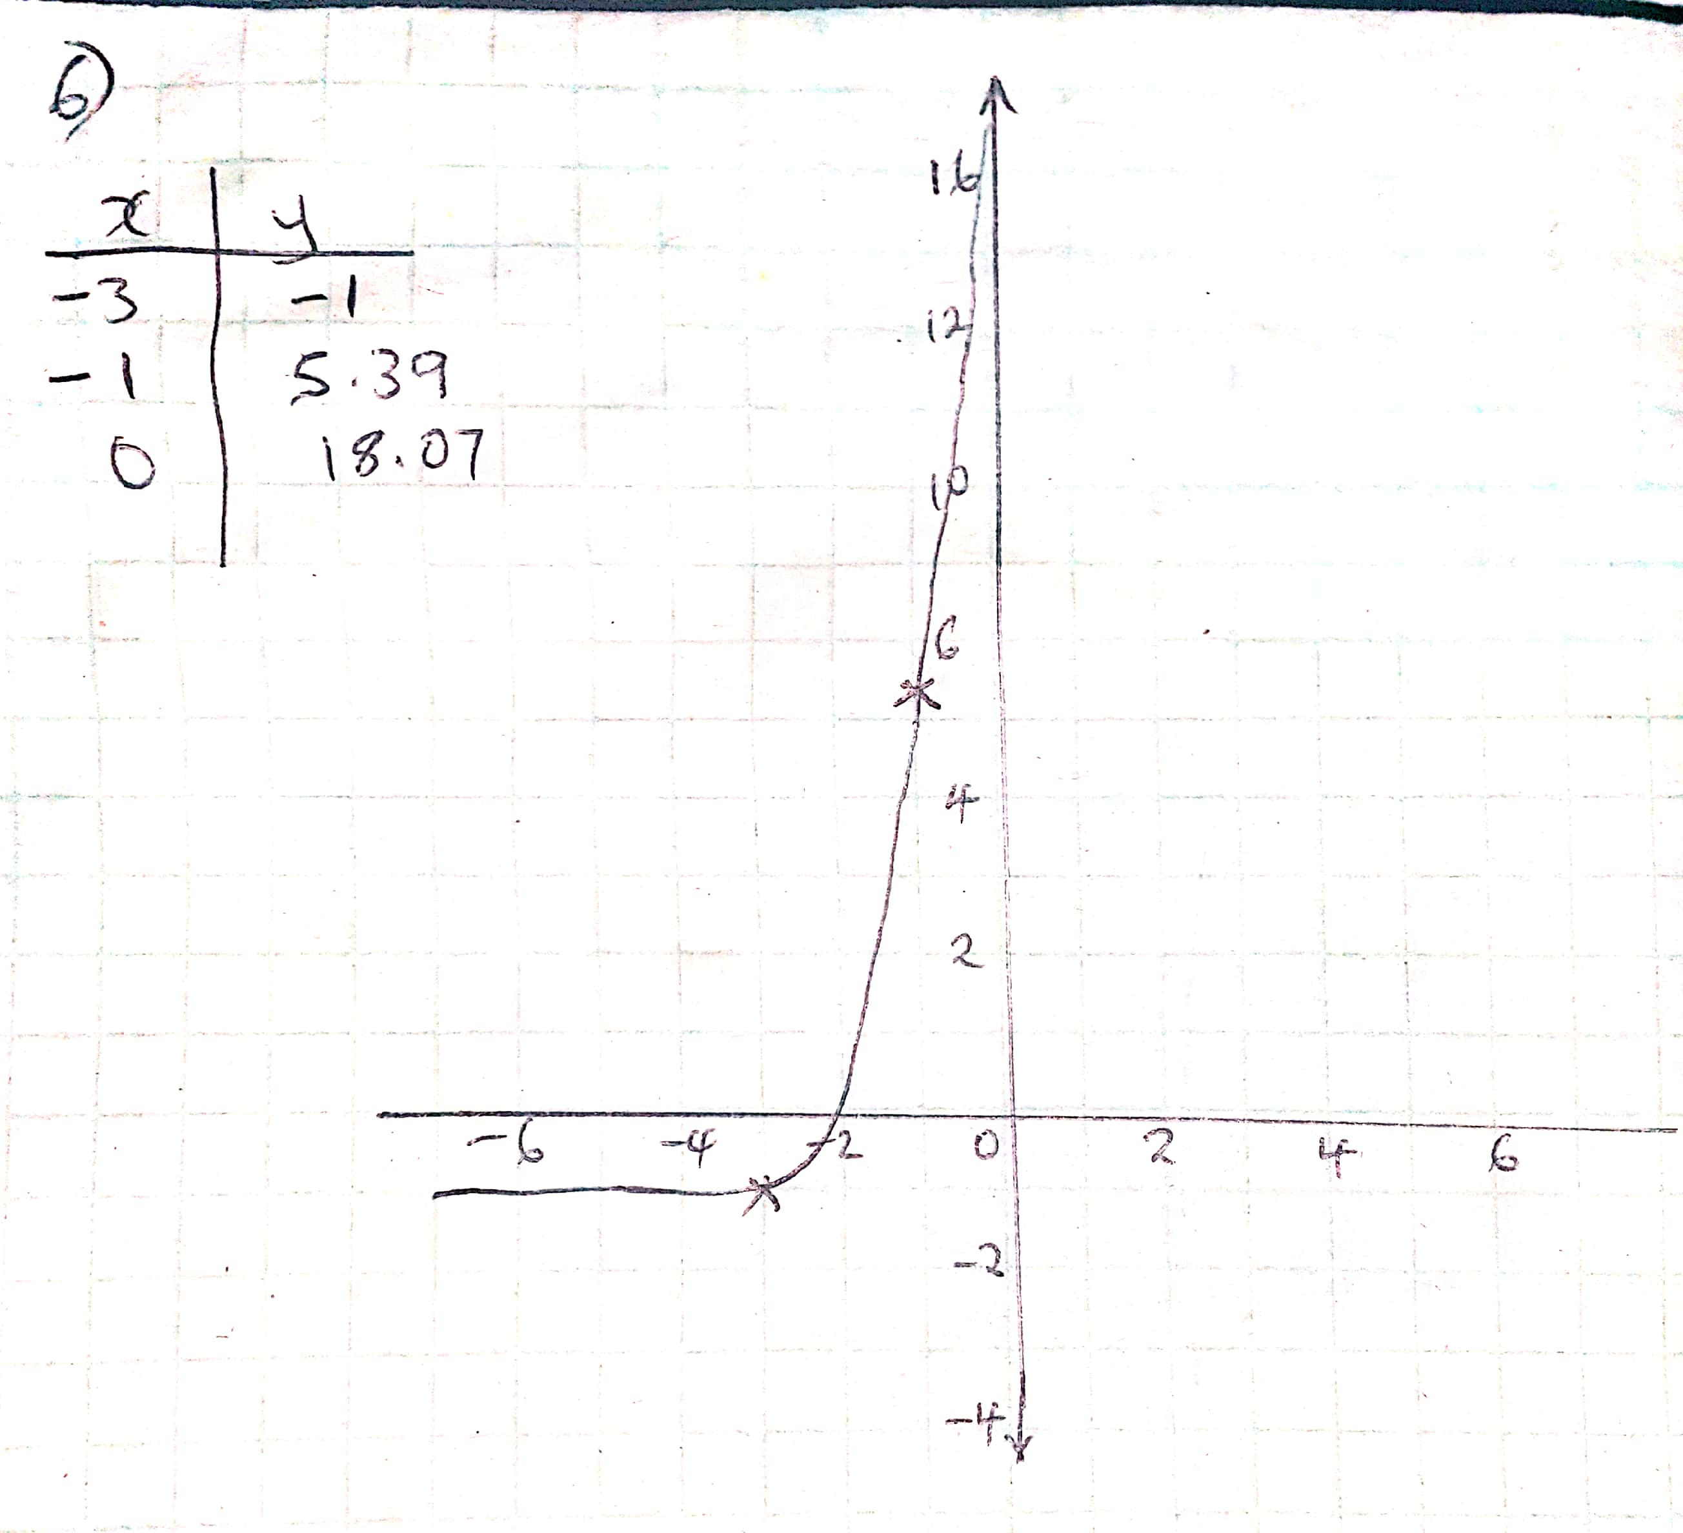
4^{5x+1} = 4²
- 5x+1 = 2
x = 1/5

- Initial value = (0,5)
F(x) = a($b^{x})$
a = 5
f(x) = 5${(b}^{x})$
using x = 4, f(x) = 80,
80 = 5${(b}^{4})$
b = 2
- F(x) = 5${(2}^{x})$

- a. log₂ 10 = x to exponential form => 2^{x} = 10
b. 15^{x} = 7 to log form => log₁₅ 7 = x
- log₄ (3x+1) = 3
- 4³ = 3x+1
64 = 3x+1
- x = 21

